**ex1_2_1**

#include "stdafx.h"

#define MAXNUM 20

#define TRUE 1

#define FALSE 0

typedef struct {

int data[MAXNUM] = { 3, 5, 9, 14, 18, 34, 56, 77 };

int length = 8;

}list_type;

void showlist(list_type *list)

{

printf("/nThis list has %d elements, and they are:", list->length);

for (int i = 0; i < list->length; i++)

printf("%d", list->data[i]);

printf("The length of the list is %d \n", list->length);

}

int insertlist(list_type *list, int new_data)

{

int i = list->length - 1;

if (list->length >= MAXNUM)

{

printf("\nInvalid operation! The list is full!");

return(FALSE);

}

for (; i >= 0 && list->data[i]>new_data; i--)

list->data[i + 1] = list->data[i];

list->data[i + 1] = new_data;

list->length++;

return(TRUE);

}

void main()

{

list_type list;

int new_data;

showlist(&list);

printf("\nPlease input the value of the element you want to insert: ");

scanf("%d\n", &new_data);

insertlist(&list, new_data);

showlist(&list);

scanf("%d\n", &new_data);

}

典型测试数据（输入）：37

应输出（上机前自己分析的结果）：3 5 9 14 18 34 37 56 77

上机时遇到的问题：无

实际运行结果：

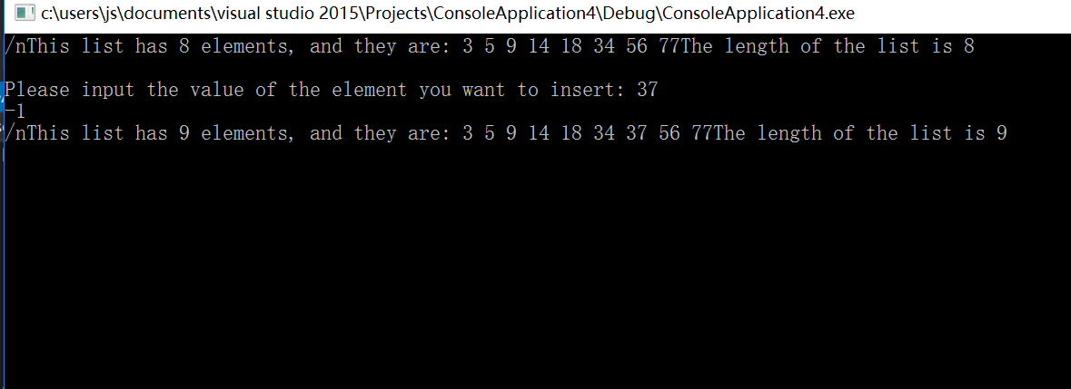

个人体会：

ex1_2_2

#include "stdafx.h"

#define MAXNUM 20

#define true 1

#define false 0

typedef struct

{

int data[MAXNUM];

int length;

}list_type;

/*create a list:input data from keyboard,end by -1*/

void createlist(list_type *list)

{

int i, elem;

list->length = 0;

printf("please input datas of the list\n");

for (i = 0; i < MAXNUM; i++)

{

scanf(" %d", &elem);

if (elem == -1) break;

list->data[i] = elem;

list->length++;

}

}

/*show the elements of the list*/

void showlist(list_type *list)

{

int i;

printf("\nThese %d records are:\n", list->length);

if (list->length <= 0)

{

printf("No data!\n");

return;

}

for (i = 0; i < list->length; i++)

printf(" %d ", list->data[i]);

printf("\nlength of the list is:%d", list->length);

}

void delete_negative(list_type *list)

{

int i = 0, j = 0;

for (; i < list->length; i++)

list->data[i] < 0 ? j++ : list->data[i - j] = list->data[i];

list->length -= j;

}

void main()

{

list_type list;

//int i ;

createlist(&list);

showlist(&list);

delete_negative(&list);

printf("\nlist after delete all negative:\n");

showlist(&list);

//scanf("%d", &i);

}

典型测试数据（输入）：5 758 9 3 1 -6 -7 -8 -4 332

应输出（上机前自己分析的结果）：5 758 9 3 1 332

上机时遇到的问题：无

实际运行结果：

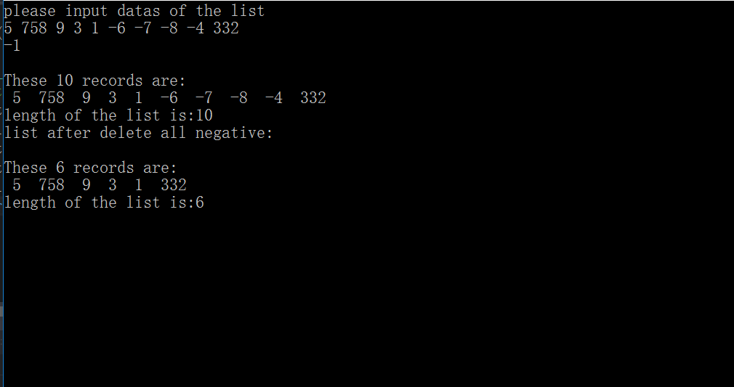

个人体会：

ex1_3

#include "stdafx.h"

#define MAXNUM 20

#define true 1

#define false 0

typedef struct

{

int data[MAXNUM];

int length;

}list_type;

/*create a list:input data from keyboard,end by -1*/

void createlist(list_type *list)

{

int i, elem;

list->length = 0;

printf("please input datas of the list\n");

for (i = 0; i < MAXNUM; i++)

{

scanf(" %d", &elem);

if (elem == -1) break;

list->data[i] = elem;

list->length++;

}

}

/*show the elements of the list*/

void showlist(list_type *list)

{

int i;

printf("\nThese %d records are:\n", list->length);

if (list->length <= 0)

{

printf("No data!\n");

return;

}

for (i = 0; i < list->length; i++)

printf(" %d ", list->data[i]);

printf("\nlength of the list is:%d", list->length);

}

void reverselist(list_type *list)

{

int n = (list->length - list->length % 2) / 2, i = 0;

int temp_data = 0;

for (; i < n; i++)

{

temp_data = list->data[i];

list->data[i] = list->data[list->length - 1 - i];

list->data[list->length - 1 - i] = temp_data;

}

}

int main()

{

list_type list;

//int i;

createlist(&list);

showlist(&list);

reverselist(&list);

printf("\nlist after delete all negative:\n");

showlist(&list);

return(0);

}

典型测试数据（输入）：983 9212 28 2 31 82 1

应输出（上机前自己分析的结果）：1 82 31 2 28 9212 983

上机时遇到的问题：无

实际运行结果：

